www.SanctusArt.com
Sanctus Catholic Art & Saints
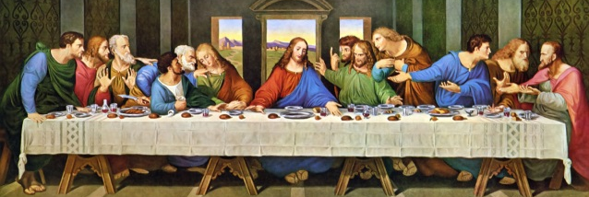
The Last Supper
On the first day of the Festival of Unleavened Bread, the disciples came to Jesus and asked, “Where do you want us to make preparations for you to eat the Passover?”
He replied, “Go into the city to a certain man and tell him, ‘The Teacher says: My appointed time is near. I am going to celebrate the Passover with my disciples at your house.’” So the disciples did as Jesus had directed them and prepared the Passover.
When evening came, Jesus was reclining at the table with the Twelve. And while they were eating, he said, “Truly I tell you, one of you will betray me.”
They were very sad and began to say to him one after the other, “Surely you don’t mean me, Lord?”
Jesus replied, “The one who has dipped his hand into the bowl with me will betray me. The Son of Man will go just as it is written about him. But woe to that man who betrays the Son of Man! It would be better for him if he had not been born.”
Then Judas, the one who would betray him, said, “Surely you don’t mean me, Rabbi?”
Jesus answered, “You have said so.”
While they were eating, Jesus took bread, and when he had given thanks, he broke it and gave it to his disciples, saying, “Take and eat; this is my body.”
Then he took a cup, and when he had given thanks, he gave it to them, saying, “Drink from it, all of you. This is my blood of the covenant, which is poured out for many for the forgiveness of sins. I tell you, I will not drink from this fruit of the vine from now on until that day when I drink it new with you in my Father’s kingdom.”
When they had sung a hymn, they went out to the Mount of Olives.

Matthew 26:26-30

