www.SanctusArt.com
Sanctus Catholic Art & Saints
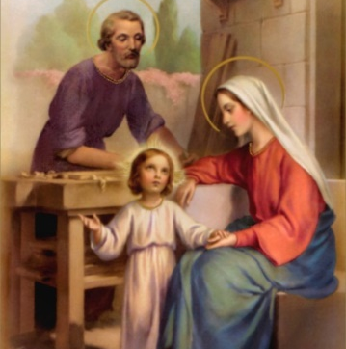
The Holy Family
Feast of the Holy Family: on the first Sunday after Christmas
Grant unto us, Lord Jesus, ever to follow the example of Thy holy Family, that in the hour of our death Thy glorious Virgin Mother together with blessed Joseph may come to meet us and we may be worthily received by Thee into everlasting dwellings: who livest and reignest world without end.
Amen.

