www.SanctusArt.com
Sanctus Catholic Art & Saints
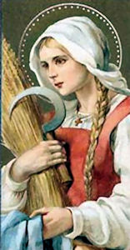
St. Zita
Feast Day : April 27
Dear follower of the Son of God, you desired to become a servant and died the death of a slave.
You were not only a faithful maid-servant but a practical lover of the poor.
Like Mary you could have said: "Behold the handmaid of the Lord."
Prompt domestics to be just and charitable, seeing in their employers children of God
and setting an example for them as servants of God.
Amen.

