www.SanctusArt.com
Sanctus Catholic Art & Saints
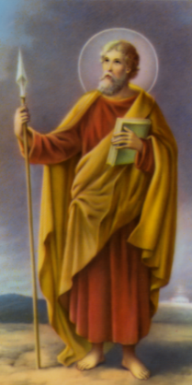
St. Thomas The Apostle
Feastday: July 3
Patron of architects

O Glorious Saint Thomas, your grief for Jesus was such that it would not let you believe he had risen unless you actually saw him and touched his wounds. But your love for Jesus was equally great and it led you to give up your life for him. Pray for us that we may grieve for our sins which were the cause of Christ's sufferings. Help us to spend ourselves in his service and so earn the title of "blessed" which Jesus applied to those who would believe in him without seeing him.
Amen.
.

