[**www.SanctusArt.com**](http://www.SanctusArt.com)

**Sanctus Catholic Art & Saints**

[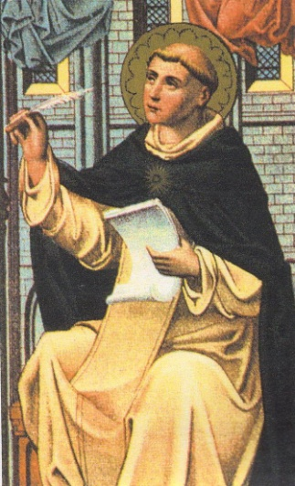](http://www.google.com/url?sa=i&rct=j&q=&esrc=s&frm=1&source=images&cd=&cad=rja&docid=zP7D2AXY3aDWXM&tbnid=Qp9X-n8OTekmgM:&ved=0CAUQjRw&url=http://dailyoffice.org/2010/01/28/evening-prayer-1-28-10-thomas-aquinas-priest-friar-1274/&ei=05dAUtHeGYGkigLai4CQAQ&psig=AFQjCNFyvR7Kofdypj4ITmXfXisVx_XQXA&ust=1380051272727553)[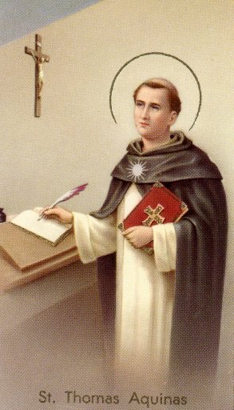](http://www.google.com/url?sa=i&rct=j&q=&esrc=s&frm=1&source=images&cd=&cad=rja&docid=WYX_DziPKAu3DM&tbnid=ycTcKtbjwMwCwM:&ved=0CAUQjRw&url=http://crawler.dipity.com/bpdrumm/personal/&ei=s5ZAUryCNeSViAKvgYGYBA&bvm=bv.52617933,d.cGE&psig=AFQjCNFE48JG4YEeNxoMFiJ-C4l26qJ_Dw&ust=1380050964788640)

**St. Thomas Aquinas**

**Feast Day: January 28th**

**“GRANT ME GRACE”  
(Prayer of St. Thomas Aquinas)**

Grant me grace, O merciful God,

to desire ardently all that is pleasing to Thee,

to examine it prudently,

to acknowledge it truthfully,

and to accomplish it perfectly,

for the praise and glory of Thy name.

Amen.