www.SanctusArt.com
Sanctus Catholic Art & Saints
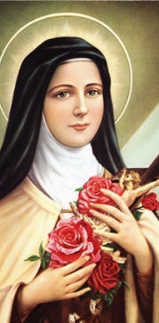
St. Therese of Lisieux
Feast Day: October 1
O little St. Theresa of the Child Jesus, who during your short life on earth became a mirror of angelic purity, of love strong as death, and of wholehearted abandonment to God, now that you rejoice in the reward of your virtues, cast a glance of pity on me as I leave all things in your hands. Make my troubles your own - speak a word for me to our Lady Immaculate, whose flower of special love you were - to that Queen of heaven "who smiled on you at the dawn of life." Beg her as the Queen of the heart of Jesus to obtain for me by her powerful intercession, the grace I yearn for so ardently at this moment, and that she join with it a blessing that may strengthen me during life. Defend me at the hour of death, and lead me straight on to a happy eternity.
Amen
.

