[**www.SanctusArt.com**](http://www.SanctusArt.com)

**Sanctus Catholic Art & Saints**

[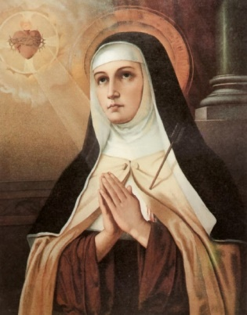](http://www.google.com/url?sa=i&rct=j&q=&esrc=s&source=images&cd=&cad=rja&uact=8&docid=rdaTC9jvBaLikM&tbnid=v00cJ_APKd17uM:&ved=0CAUQjRw&url=http://yosoylucialaluzdelmundo.blogspot.com/2014/01/estrella-aqui-en-encarnacion-en-la-luz.html&ei=3EVwU7zCNtDpoATAtIGoBA&bvm=bv.66330100,d.cGU&psig=AFQjCNHFbjk0_3fHNpMwSkcCAZvvBj_xig&ust=1399953190901813)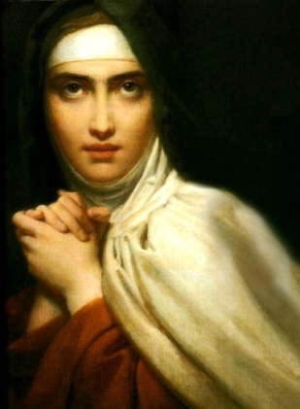

S**t. Teresa of Avila**

**Feast Day: October 15**

**The patron of Headache sufferers**

Dear wonderful saint, model of fidelity to vows, you gladly carried a heavy cross following in the steps of Christ who chose to be crucified for us. You realized that God like a merciful Father chastises those whom He loves--- which to worldings seems silly indeed. Grant to N. relief from great pains if this is in line with God's plan.

Amen.