www.SanctusArt.com
Sanctus Catholic Art & Saints
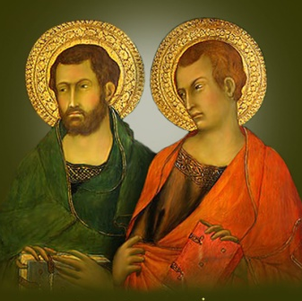
St. Simon and St. Jude
Feast Day: October 28th
O God, we thank thee for the glorious company of the apostles, and especially on this day for Simon and Jude; and we pray that, as they were faithful and zealous in their mission, so we may with ardent devotion make known the love and mercy of our Lord and Savior Jesus Christ; who liveth and reigneth with thee and the Holy Spirit, one God, for ever and ever.
Amen.

