www.SanctusArt.com
Sanctus Catholic Art & Saints
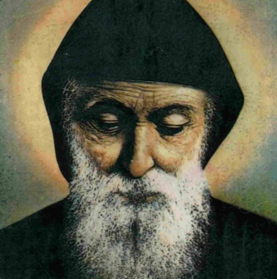
St. Sharbel
Lord God,
you kept St. Sharbel faithful to Christ’s pattern of poverty and humility.
May his prayers help us to live in fidelity to our calling
and bring us to the perfection you have shown us in your Son,
who lives and reigns with you and the Holy Spirit,
one God, forever and ever.
Amen.

