[**www.SanctusArt.com**](http://www.SanctusArt.com)

**Sanctus Catholic Art & Saints**

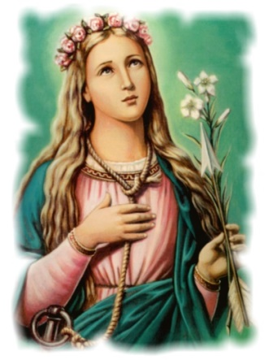[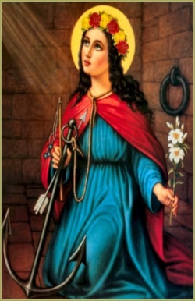](http://www.google.com/url?sa=i&rct=j&q=&esrc=s&frm=1&source=images&cd=&cad=rja&docid=u3WGHmrdqu38WM&tbnid=QleNz2iNGP--6M:&ved=0CAUQjRw&url=http://www.catholictradition.org/Saints/philomena2.htm&ei=zk0hUde2DOffiAK47YDABA&psig=AFQjCNEbeQAzP0My7rgfbUh-faefbk7Q1Q&ust=1361223476279663)

**St. Philomena**

**Feast Day: August 11**

O most pure Virgin, glorious Martyr, St. Philomena, whom God in His eternal power has revealed to the world in these unhappy days in order to revive the faith, sustain the hope and enkindle the charity of Christian souls, behold me prostate at thy feet. Deign, O Virgin, full of goodness and kindness, to receive my humble prayers and to obtain for me that purity for which thou didst sacrifice the most alluring pleasures of the world, that strength of soul which made thee resist the most terrible attacks and that ardent love for our Lord Jesus Christ, which the most frightful torments could not extinguish in thee. So, that wearing thy holy cord and imitating thee in this life, I may one day be crowned with thee in heaven. Amen.