www.SanctusArt.com
Sanctus Catholic Art & Saints
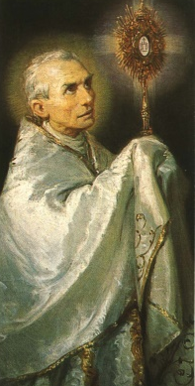
St. Peter Julian Eymard
Feast Day: August 2

Gracious God of our ancestors,
you led Peter Julian Eymard,
like Jacob in times past,
on a journey of faith.
Under the guidance of your gentle Spirit,
Peter Julian discovered the gift of love in the Eucharist
which your son Jesus offered for the hungers of humanity.
Grant that we may celebrate this mystery worthily, adore it profoundly,
and proclaim it prophetically for your greater glory. Amen.

