www.SanctusArt.com
Sanctus Catholic Art & Saints
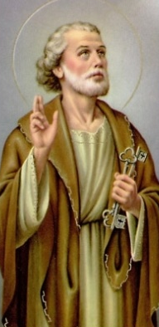
St. Peter
Feast Day: June 29th
O Glorious Saint Peter, because of your vibrant and generous faith, sincere humility and flaming love our Lord honored you with singular privileges and especially leadership of the whole Church. Obtain for us the grace of a living faith, a sincere loyalty to the Church, acceptance of all her teaching, and obedience to all her precepts. Let us thus enjoy an undisturbed peace on earth and everlasting happiness in heaven.
Amen

