www.SanctusArt.com
Sanctus Catholic Art & Saints
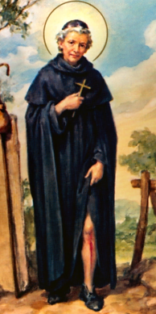
St. Peregrine Laziosi
Feast Day: May 1st
Patron of Cancer Patients
O great St. Peregrine, you have been called "The Mighty," "The Wonder-Worker," because of the numerous miracles which you have obtained from God for those who have had recourse to you.
For so many years you bore in your own flesh this cancerous disease that destroys the very fiber of our being, and who had recourse to the source of all grace when the power of man could do no more. You were favored with the vision of Jesus coming down from His Cross to heal your affliction. Ask of God and Our Lady, the cure of the sick whom we entrust to you.
(Pause here and silently recall the names of the sick for whom you are praying)
Aided in this way by your powerful intercession, we shall sing to God, now and for all eternity, a song of gratitude for His great goodness and mercy.

