www.SanctusArt.com
Sanctus Catholic Art & Saints
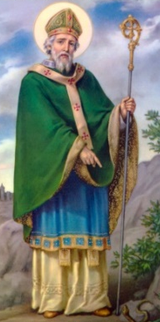
St. Patrick
Feast Day: March 17
Patron of Ireland
As I arise today, may the strength of God pilot me,
the power of God uphold me, the wisdom of God guide me.
May the eye of God look before me, the ear of God hear me,
the word of God speak for me. May the hand of God protect me,
the way of God lie before me, the shield of God defend me,
the host of God save me. May Christ shield me today.
Christ with me, Christ before me, Christ behind me,
Christ in me, Christ beneath me, Christ above me,
Christ on my right, Christ on my left,
Christ when I lie down, Christ when I sit, Christ when I stand,
Christ in the heart of everyone who thinks of me,
Christ in the mouth of everyone who speaks of me,
Christ in every eye that sees me, Christ in every ear that hears me.
Amen

