www.SanctusArt.com
Sanctus Catholic Art & Saints
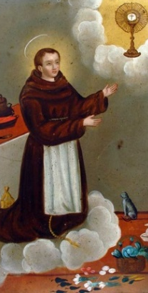
St. Pascual Bailon
Feast Day: May 17th
“Patron of Cooks and Kitchens”
Paschal, illustrious is thy name, But brighter glows thy virtue's fame; With many a sign thy works are crowned; Through thee God's gifts to men abound. From Heaven look down, we humbly pray, On us who seek thine aid this day; Remove the evil that we dread, And grant us what we ask instead. And when to Heaven's high feast we go, The nuptial robe on us bestow, That Christ our strength and food may be, In death and for eternity. From Heaven look down... Glory be to the Father, and to the Son, and to the Holy Ghost. From Heaven look down... V. Pray for us, O blessed Paschal, R. That we may be made worthy of the promises of Christ. Let us pray. O God, who hast glorified blessed Paschal Thy Confessor by a wonderful love for the sacred mysteries of Thy Body and Blood: mercifully grant that we also, like him, may deserve to taste the spiritual sweetness of this divine Supper: Who livest and reignest world without end. Amen.

