www.SanctusArt.com
Sanctus Catholic Art & Saints
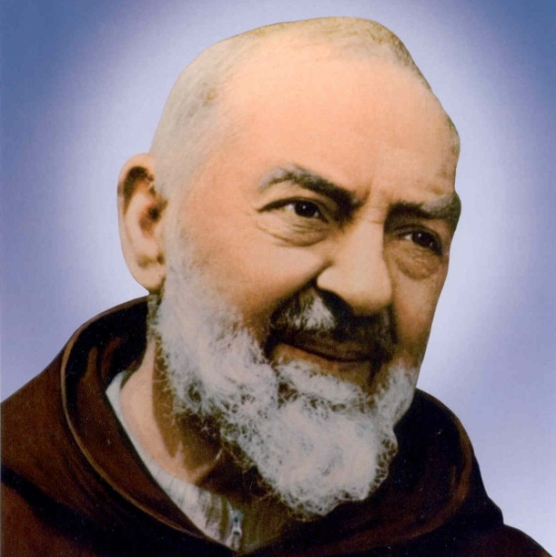
St. Padre Pio
Feast Day: September 23
Dear God, You generously blessed Your servant, St. Pio of Pietrelcina, with the gifts of the Spirit. You marked his body with the five wounds of Christ Crucified, as a powerful witness to the saving Passion and Death of Your Son. Endowed with the gift of discernment, St. Pio labored endlessly in the confessional for the salvation of souls. With reverence and intense devotion in the celebration of Mass, he invited countless men and women to a greater union with Jesus Christ in the Sacrament of the Holy Eucharist. Through the intercession of St. Pio of Pietrelcina, I confidently beseech You to grant me the grace of (here state your petition). Glory be to the Father… (three times). Amen.

