www.SanctusArt.com
Sanctus Catholic Art & Saints
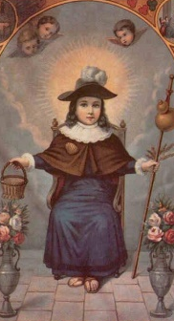
El Santo Nino De Atocha
O Miraculous Infant of Atocha!
Cast Thy merciful look upon my troubled heart, so inclined to pity. Be softened by my prayer, and grant me these favors which I ardently implore of Thee (Mention requests).
Take from me all affliction and despair, all trials and misfortunes with which I am laden. For Thy Sacred Infancy’s sake, send me now the consolation and aid and grace that I may praise Thee with the Father and Holy Ghost, forever and ever. Amen
O Divine Child of Atocha, hear my prayer and grant my petition.

