www.SanctusArt.com
Sanctus Catholic Art & Saints
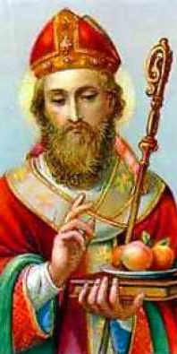
St. Nicholas
Feast Day: December 6th
Patron of Children
God, Our Father, we pray that through Your intercession of St. Nicholas You will protect our children. Keep them safe from harm and help them grow and become worthy in Your sight. Give them strength to keep their Faith in You; and to keep alive their joy in Your creation. Through Jesus Christ, Our Lord. Amen.

