www.SanctusArt.com
Sanctus Catholic Art & Saints
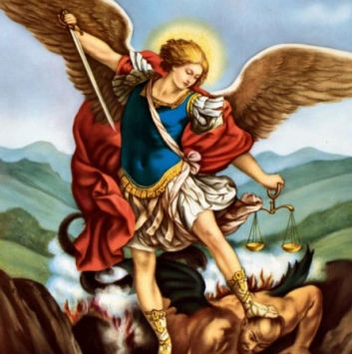
St. Michael, the Archangel
Feast Day: September 29
Patron of Policemen, Paratroopers, & Grocers

Saint Michael the Archangel, defend us in battle, be our protection against the wickedness and snares of the devil; may God rebuke him, we humbly pray and do thou, O Prince of the heavenly host, by the power of God, thrust into hell Satan and all evil spirits who wander through the world for the ruin of souls.
Amen.

