www.SanctusArt.com
Sanctus Catholic Art & Saints
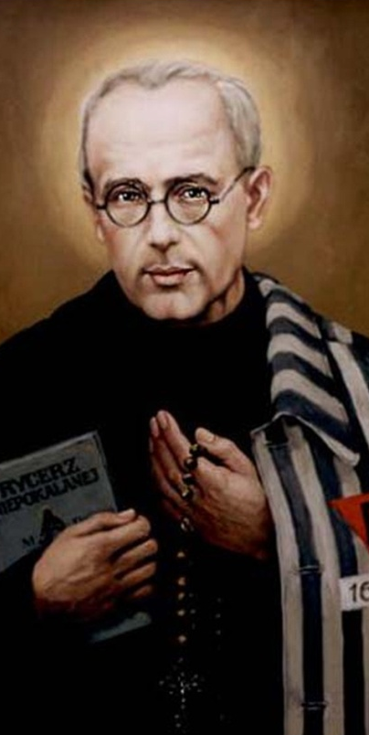
St. Maximilian Kolbe
Feast Day: August 14
Patron saint of drug addicts
St. Maximilian, amidst the hate and lonely misery of Auschwitz, you brought love into the lives of fellow captives and sowed the seeds of hope amidst despair. You bore witness to the world by word and deed that "Love alone creates." Help me to become more like you. With the Church and Mary and you, may I proclaim that "Love alone creates." To the hungry and oppressed, the naked and homeless, the scorned and hated, the lonely and despairing, may I proclaim the power of Christ's love, which endures forever and ever. Amen.

