www.SanctusArt.com
Sanctus Catholic Art & Saints
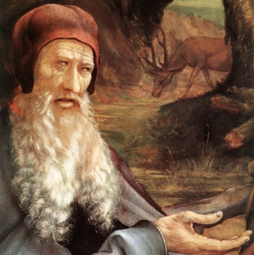
St. Matthias, Apostle
Feast Day: May 14th

Father, you called Saint Matthias to share in the mission of the apostles.
By the help of his prayers may we receive with joy the love you share with us and be counted among those you have chosen. Through our Lord Jesus Christ, your Son, who lives and reigns with you in the unity of the Holy Spirit, one God, for ever and ever.
Amen.

