www.SanctusArt.com
Sanctus Catholic Art & Saints
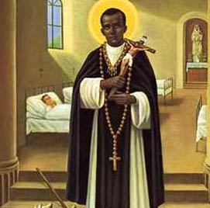
St. Martin De Porres
Feast Day: November 3rd

To you Saint Martin de Porres we prayerfully lift up our hearts filled with serene confidence and devotion. Mindful of your unbounded and helpful charity to all levels of society and also of your meekness and humility of heart, we offer our petitions to you. Pour out upon our families the precious gifts of your solicitous and generous intercession; show to the people of every race and every color the paths of unity and of justice; implore from our Father in heaven the coming of his kingdom, so that through mutual benevolence in God men may increase the fruits of grace and merit the rewards of eternal life. Amen.

