www.SanctusArt.com
Sanctus Catholic Art & Saints
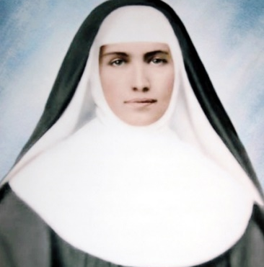
St. Marianne Cope
Feast Day: January 23
Lord Jesus, you who gave us your commandment of love of God and neighbor, and identified yourself in a special way with the most needy of your people, hear our prayer. Faithful to your teaching, St. Marianne Cope loved and served her neighbor, especially the most desolate outcast, giving herself generously and heroically for those afflicted by leprosy. She alleviated their physical and spiritual sufferings, thus helping them to accept their afflictions with patience. Her care and concern for others manifested the great love you have for us. Through her merits and intercession, grant us the favor which we confidently ask of you so that the people of God, following the inspiration of her life and apostolate, may practice charity towards all according to your word and example. Amen.

