www.SanctusArt.com
Sanctus Catholic Art & Saints
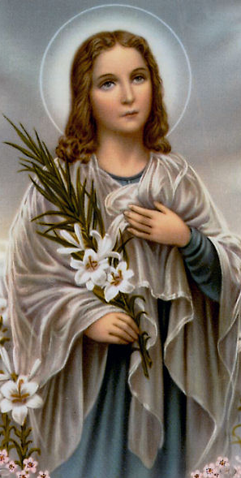
St. Maria Goretti
Feast Day: July 6
Patron of youth, young women, purity, and victims of rape
Oh Saint Maria Goretti who, strengthened by God's grace, did not hesitate even at the age of twelve to shed your blood and sacrifice life itself to defend your virginal purity, look graciously on the unhappy human race which has strayed far from the path of eternal salvation. Teach us all, and especially youth, with what courage and promptitude we should flee for the love of Jesus anything that could offend Him or stain our souls with sin. Obtain for us from our Lord victory in temptation, comfort in the sorrows of life, and the grace which we earnestly beg of thee (here insert intention), and may we one day enjoy with thee the imperishable glory of Heaven. Amen.

