www.SanctusArt.com
Sanctus Catholic Art & Saints
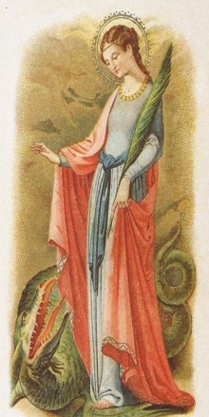
St. Margaret of Antioch
Feast Day: July 20
Patron saint of pregnancy, labor and childbirth
Margaret, holy virgin and martyr, thou didst faithfully preserve the robe of holy innocence and purity, valiantly resisting all the blandishments and allurements of the world for the love of thy divine Spouse, Jesus Christ; help me to overcome all temptations against the choicest of all virtues, holy purity, and to remain steadfast in the love of Christ, in order to preserve this great gift of God. Implore for me the grace of perseverance in prayer, distrust of myself, and flight from the occasions of sin, and finally the grace of a good death, so that in heaven I may "follow the Lamb whithersoever He goeth."
Amen.

