[**www.SanctusArt.com**](http://www.SanctusArt.com)

**Sanctus Catholic Art & Saints**

[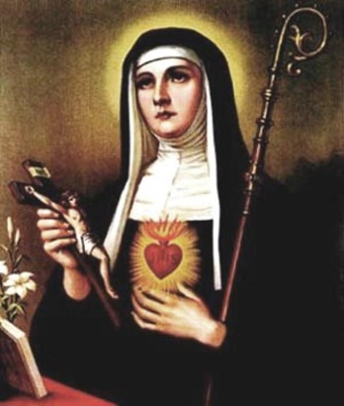](http://www.google.com/url?sa=i&rct=j&q=&esrc=s&frm=1&source=images&cd=&cad=rja&docid=D1Ufs1YBNOtzDM&tbnid=PmROzOeQw3lVQM:&ved=0CAUQjRw&url=http://0034c81.netsolhost.com/stmargaretmary.html&ei=Dr8qUeCYIqiUigKi0IDQDg&bvm=bv.42768644,d.cGE&psig=AFQjCNGK68_NRcW7YQSu6DkbAScAAGJ8Yw&ust=1361842310222259)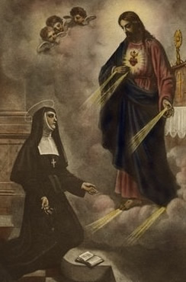

**St. Margaret Mary Alacoque**

**Feast Day: October 17**

Saint Margaret Mary, thou who wast made a partaker of the divine treasures of the Sacred Heart of Jesus, obtain for us, we beseech thee, from this adorable Heart, the graces we need so sorely. We ask these favors of thee with unbounded confidence. May the divine Heart of Jesus be pleased to bestow them upon us through thy intercession, so that once again He may be loved and glorified through thee.

Amen.