www.SanctusArt.com
Sanctus Catholic Art & Saints
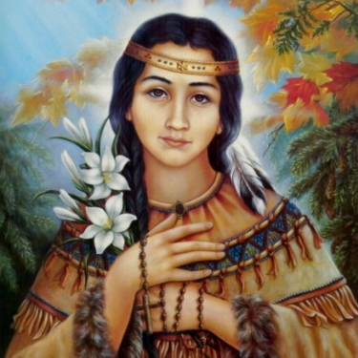
St. Kateri Tekakwitha
Feast Day: July 14
Patron Saint of the environment and ecology
St. Kateri, Star of Native People and Bright Light for all! We thank God for your heroic courage, constant perseverance and deep love of the Cross. Pray for us that our love for Christ may deepen. And may we imitate you in following God's Will even when difficulties arise. In Jesus' name we pray.
Amen

