[**www.SanctusArt.com**](http://www.SanctusArt.com)

**Sanctus Catholic Art & Saints**

[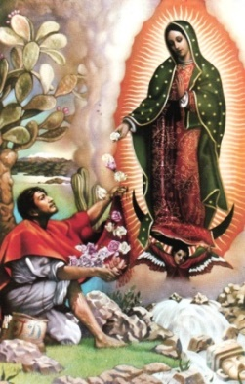](http://www.google.com/url?sa=i&rct=j&q=&esrc=s&frm=1&source=images&cd=&cad=rja&docid=pTOiBxd2ply3HM&tbnid=im8AaMuJBKBELM:&ved=0CAUQjRw&url=http://allaboutmary.tumblr.com/page/222&ei=GiElUsqzE8bBigLywoDABQ&bvm=bv.51495398,d.cGE&psig=AFQjCNGKYs7W-EjV5HGvgOihkuAjevqj3w&ust=1378251253650761)[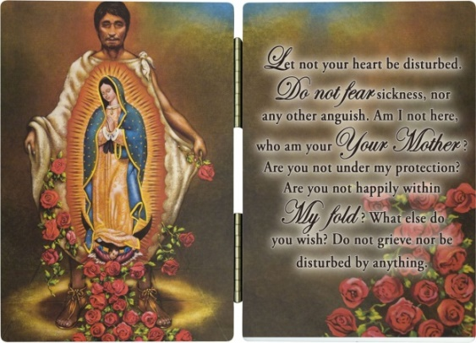](http://www.google.com/url?sa=i&rct=j&q=&esrc=s&frm=1&source=images&cd=&cad=rja&docid=Y8fMssRWq4zBrM&tbnid=uLNDz3u9mTYY9M:&ved=0CAUQjRw&url=http://www.catholictothemax.com/products.php?product=St.-Juan-Diego-Diptych&ei=yCAlUv2KEM2bjAL_34GwBA&bvm=bv.51495398,d.cGE&psig=AFQjCNGKYs7W-EjV5HGvgOihkuAjevqj3w&ust=1378251253650761)

**St. Juan Diego**

**Feast Day: December 9**  
You who were chosen by Our Lady of Guadalupe as an instrument to show your people and the world that the way of Christianity is one of love, compassion, understanding, values, sacrifices, repentance of our sins, appreciation and respect for God’s creation, and most of all one of humility and obedience;

You whom we know is now in the Kingdom of the Lord and close to our Mother;

Be our angel and protect us, stay with us as we struggle in this modern life often not knowing where to set our priorities;

Help us to pray to our God to obtain the gifts of the Holy Spirit and use them for the good of humanity and the good of our Church, through the Heart of Our Lady of Guadalupe to the Heart of Jesus. Amen.