www.SanctusArt.com
Sanctus Catholic Art & Saints
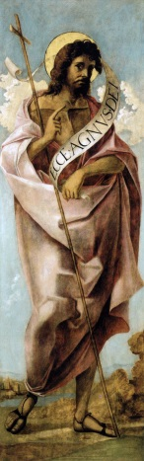
St. John the Baptist
Feast Day: June 24th
O God, You raised up St. John the Baptist to prepare a perfect people for Christ. Fill Your people with the joy of possessing His grace, and direct the minds of all the faithful in the way of peace and salvation.
Grant that as St. John was martyred for truth and justice, so we may energetically profess our Faith in You, and lead others to the Way, the Truth, and Eternal Life.
Amen.

