www.SanctusArt.com
Sanctus Catholic Art & Saints
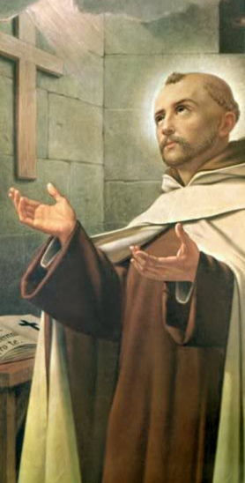
St. John of the Cross
Feast Day: December 17th
Saint John of the Cross, in the darkness of your worst moments, when you were alone and persecuted, you found God. Help me to have faith that God is there especially in the times when God seems absent and far away. Amen

