www.SanctusArt.com
Sanctus Catholic Art & Saints
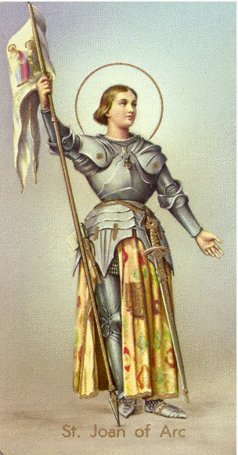
St. Joan of Arc
Feast Day: May 30
Dear Sweet Patron Saint,
I implore you in the name of God to intercede on my behalf and guide me. Help me to be strong when people are against me and question my belief in God. Help me to stand by my faith and my decisions concerning my faith. I wish to do only God's will, and I beg of you, O Patron Saint, to help keep me on His true path, and guide me in His will. I need friends now, more than ever before, and I choose God as my first and foremost best friend, above all others. But I also choose you as a close and special friend to relate to and to talk to. Please counsel me by any means necessary that is in the will of God to do. Please let me have the wisdom and understanding to receive his message and the patience and virtue to listen so that I may understand his word.
St. Joan, Pray for us.
Amen.

