[**www.SanctusArt.com**](http://www.SanctusArt.com)

**Sanctus Catholic Art & Saints**

[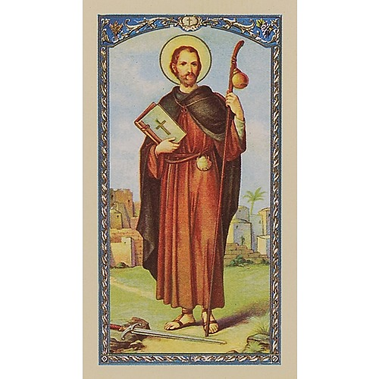](https://www.google.com/url?sa=i&rct=j&q=&esrc=s&source=images&cd=&cad=rja&uact=8&ved=0ahUKEwjpm9i68pPSAhUlilQKHX6jDbIQjRwIBw&url=https://www.catholiccompany.com/prayer-to-st-james-prayer-card-i20765/&psig=AFQjCNE4nBpmX1ZiV_hXVzMZuBqf9U9L_g&ust=1487309670878961)**[](https://www.pinterest.com/pin/284008320222981457/)**

**St. James the Greater**

**Feast Day: July 25th**

O glorious Apostle, St. James, who by reason of thy fervent and generous heart wast chosen by Jesus to be a witness of His glory on Mount Tabor, and of His agony in Gethsemane; thou, whose very name is a symbol of warfare and victory: obtain for us strength and consolation in the unending warfare of this life, that, having constantly and generously followed Jesus, we may be victors in the strife and deserve to receive the victor's crown in heaven. Amen.