[**www.SanctusArt.com**](http://www.SanctusArt.com)

**Sanctus Catholic Art & Saints**

[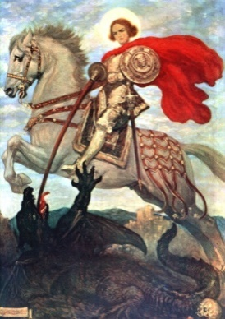](http://www.google.com/url?sa=i&rct=j&q=&esrc=s&source=images&cd=&cad=rja&uact=8&docid=0FjxFrsFGJOD2M&tbnid=lm_SdBXhcBog4M:&ved=0CAYQjRw&url=http://karlshuker.blogspot.com/2012/04/st-george-and-polymorphic-dragon.html&ei=SeEjU-LwNpDaoASf6YCwBQ&bvm=bv.62922401,d.cGU&psig=AFQjCNFCU-IPa6vyRtUUADmn1GzARTjniA&ust=1394946257143234)****[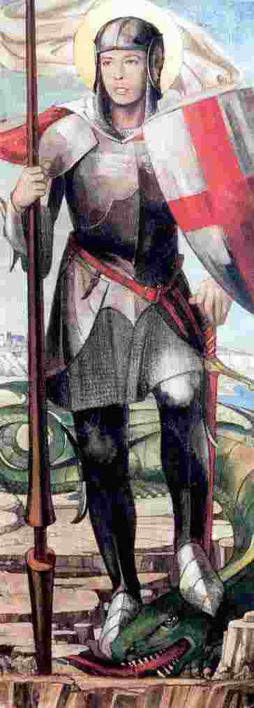](http://www.google.com/url?sa=i&rct=j&q=&esrc=s&source=images&cd=&cad=rja&uact=8&docid=M8UQTM7jAxPveM&tbnid=Tu6JnHyfSpnwdM:&ved=0CAYQjRw&url=http://theoldcatholic.blogspot.com/2010/04/for-england-and-st-george-henry-v.html&ei=Z98jU_WBJcrpoATFtICgAw&bvm=bv.62922401,d.cGU&psig=AFQjCNFCU-IPa6vyRtUUADmn1GzARTjniA&ust=1394946257143234)

**St. George**

**Feast Day: April 23rd**

**Patron of England & Catalonia**

St. George, Heroic Catholic soldier and defender of your Faith, you dared to criticize a tyrannical Emperor and were subjected to horrible torture. You could have occupied a high military position but you preferred to die for your Lord. Obtain for us the great grace of heroic Christian courage that should mark soldiers of Christ.

Amen