www.SanctusArt.com
Sanctus Catholic Art & Saints
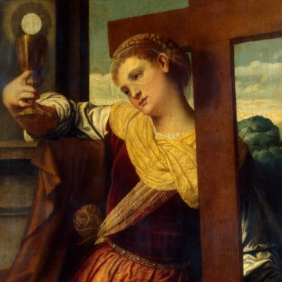

St. Faith
Feast Day: October 6th
Lord Jesus, who art always ready to assist your servants, fortify me at this hour, and enable me to answer in a manner worthy of you.
-- Saint Faith from a prayer attributed to her during her trial

