www.SanctusArt.com
Sanctus Catholic Art & Saints
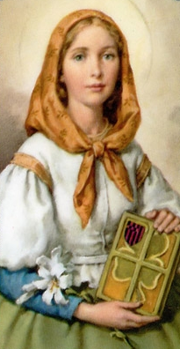
St. Dymphna
Feast Day: May 15
Patron of those suffering for nervous and mental afflictions
Good Saint Dymphna, great wonder-worker in every affliction of mind and body, I humbly implore your powerful intercession with Jesus through Mary, the Health of the Sick, in my present need. (Mention it.) Saint Dymphna, martyr of purity, patroness of those who suffer with nervous and mental afflictions, beloved child of Jesus and Mary, pray to Them for me and obtain my request. Amen
(Pray one Our Father, one Hail Mary and one Glory Be.)
Saint Dymphna, Virgin and Martyr, pray for us.
.

