www.SanctusArt.com
Sanctus Catholic Art & Saints
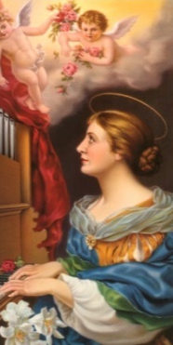
St. Cecilia
Feast Day: November 22
Patron of Musicians
O glorious saint, who chose to die Instead of denying your King.
We pray you please to help us As His fair praise we sing!
We lift our hearts in joyous son To honor Him this way,
And while we sing, remembering, To sing is to doubly pray.
At once in our hearts and in our tongues We offer double prayer
Sent heavenward on winged notes To praise God dwelling there.
While in our hearts and tongues we try With song to praise God twice,
We ask dear saint, to help us be United closed to Christ!

