www.SanctusArt.com
Sanctus Catholic Art & Saints
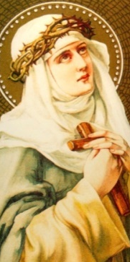
St. Catherine of Sienna
Feast Day: April 30
Dominican Tertiary and Doctor of the Church, you were full of wisdom, the special gift of God, and you knew how to guide even Pontiffs, as well as how to extinguish fiery passions and restore true peace among people. How inspiring your spiritual writings and how heroic your abstemious life!
Fires are today unfortunately all too common, some even caused by criminal persons. Please protect and encourage firefighters in their heroic efforts to save lives. Amen.

