www.SanctusArt.com
Sanctus Catholic Art & Saints
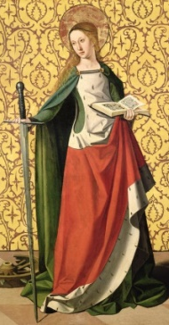
St. Catherine of Alexandria
Feast Day: November 25th
Glorious Saint Catherine, virgin and martyr, help me to imitate your love of purity. Give me strength and courage in fighting off the temptations of the world and evil desires. Help me to love God with my whole heart and serve Him faithfully. O Saint Catherine, through your glorious martyrdom for the love of Christ, help me to be loyal to my faith and my God as long as I live.

