www.SanctusArt.com
Sanctus Catholic Art & Saints
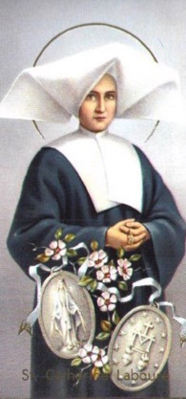
St. Catherine Laboure
Feast Day: November 28
Patron Saint of Photographers
Saint Catherine Labouré, you were the chosen confidant of the Blessed Virgin Mary. She revealed to you her desire that her children wear the Miraculous Medal as a mark of their love for her and in honor of her Immaculate Conception.
Intercede for us, that we may follow our heavenly mother's desires. Ask that we may receive those special graces which flow from her motherly hands like rays of light.
Amen
.

