www.SanctusArt.com
Sanctus Catholic Art & Saints
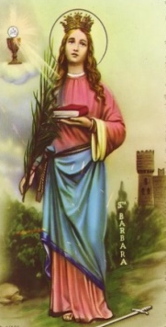
St. Barbara
Feast Day December 4
St Barbara, you are stronger than the tower of a fortress and the fury of hurricanes. Do not let lightning hit me, thunder frighten me or the roar of canons jolt my courage or bravery. Stay always by my side so that I may confront all the storms and battles of my life with my head held high and a serene countenance. Winning all the struggles, may I, aware of doing my duty, be grateful to you, my protector, and render thanks to God, the Creator of heaven, earth and nature who has the power to dominate the fury of the storm and to mitigate the cruelty of war.
St Barbara, pray for us.
Amen.

