[**www.SanctusArt.com**](http://www.SanctusArt.com)

**Sanctus Catholic Art & Saints**

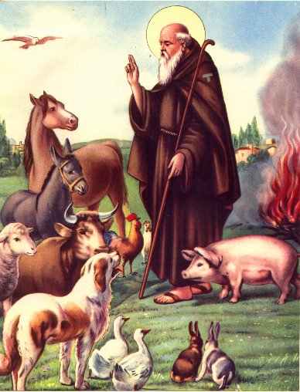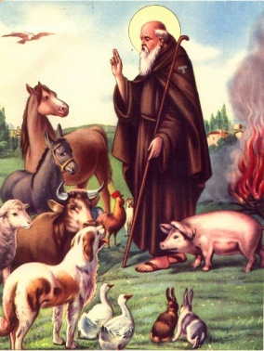

St. Anthony the Abbot

Feast Day: January 17th

Dear God, St. Anthony the Abbot accepted your call to renounce the world and to love you above all things. He faithfully served you in the solitude of the desert by fasting, prayer, humility and good works. In the *Sign of The Cross*, he triumphed over the Devil. Through his intercession, may we learn to love you better; with all our hearts, all our souls, all our minds, all our strength and to love our neighbors as we love ourselves. We ask this through our lord Jesus Christ, who lives and reigns with God the Father and the Holy Spirit. One God forever and ever, Amen.