www.SanctusArt.com
Sanctus Catholic Art & Saints
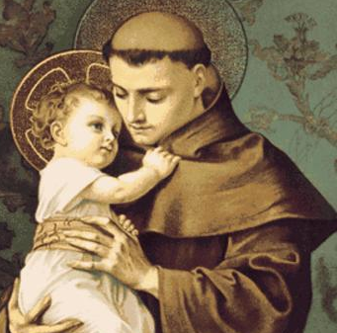
St. Anthony of Padua
Patron of Seekers of Lost Articles & Patron of the Poor
Feast Day: June 13
O Holy St. Anthony, gentlest of Saints, you love for God and Charity for His creatures, made you worthy, when on earth, to possess miraculous powers. Miracles waited on your word, which you were ever ready to speak for those in trouble or anxiety. Encouraged by this thought, I implore of you to obtain for me (state request here). The answer to my prayer may require a miracle, even so, you are the Saint of Miracles.
O gentle and loving St. Anthony, whose heart was ever full of human sympathy, whisper my petition into the eaars of the Sweet Infant Jesus, who loved to be folded in your arms; and the gratitude of my heart will ever be yours. Amen.
(Then say the Our Father, Hail Mary, and Glory Be)

