www.SanctusArt.com
Sanctus Catholic Art & Saints
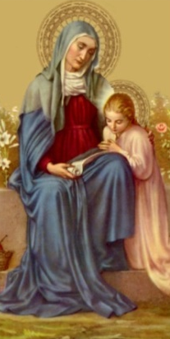
St. Anne
Feast Day: July 26
Patron saint of housewives, grandmothers, grandparents & mothers

Good St. Anne, you were especially favored by God to be the mother of the most holy Virgin Mary, the Mother of our Savior. By your power with your most pure daughter and with her divine Son, kindly obtain for us the grace and the favor we now seek. Please secure for us also forgiveness of our past sins, the strength to perform faithfully our daily duties and the help we need to persevere in the love of Jesus and Mary.
Amen.

