www.SanctusArt.com
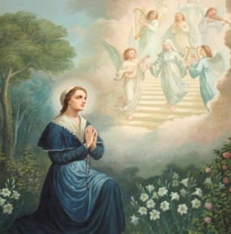
Sanctus Catholic Art & Saints

St. Angela
Feast Day: January 27th
May the Virgin Saint Angela never fail to commend us to Your compassion, O Lord, we pray,
that, following the lessons of her charity and prudence, we may hold fast to Your teaching
and express it in what we do. Through our Lord Jesus Christ, Your Son,
who lives and reigns with You in the unity of the Holy Spirit, one God, for ever and ever.
Amen.

