**[www.SanctusArt.com](http://www.SanctusArt.com)**

**Sanctus Catholic Art & Saints**

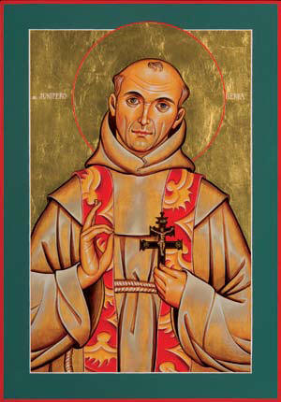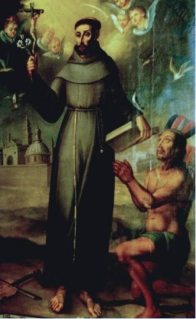

**St. Junipero Serra**

**Feast Day: July 1st**

**Patron of Vocations**

"Walk with St. Junipero Serra as he traces our Lord's footsteps in search of workers for the vineyard."

Holy Spirit, you are the love and light of the world. Continue to give all Serrans the courage and generosity to respond ardently to your call.

With one voice now, all Serrans say, "Here I am Lord." Fire each of us with a renewed spirit and enthusiasm to work for vocations for our Church.

Deepen our commitment to the Serran mission that we may, indeed, walk "in his steps" on our journey.

Father, we ask this in the name of Jesus, our Lord, through the intercession of Blessed Junipero Serra and Mary, the Mother of the Church and religious vocations.

Amen