[**www.SanctusArt.com**](http://www.SanctusArt.com)

**Sanctus Catholic Art & Saints**

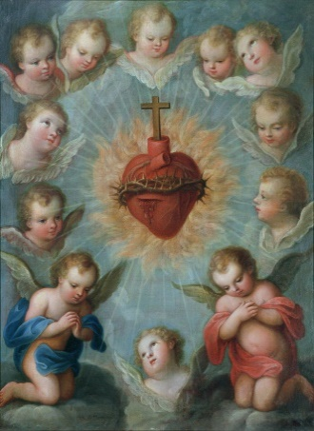[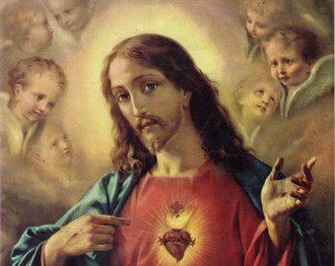](http://www.google.com/url?sa=i&rct=j&q=&esrc=s&frm=1&source=images&cd=&cad=rja&docid=MULA3Pxm3azRVM&tbnid=y7ERjlRqeBv3TM:&ved=0CAUQjRw&url=http://www.etsy.com/market/Coraz%C3%B3n?ref%3Dlisting_tag&ei=Rzw_Uu7sFeGviQKZiYDICg&psig=AFQjCNELlT63FXXTivSM3l4gaQAIDt9bbA&ust=1379961816296407)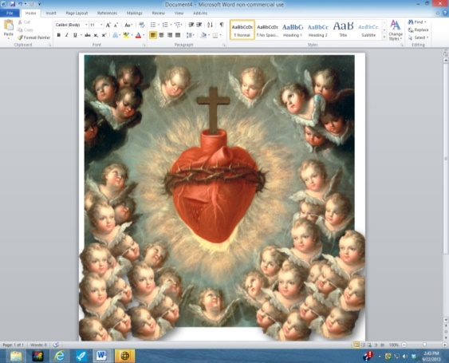[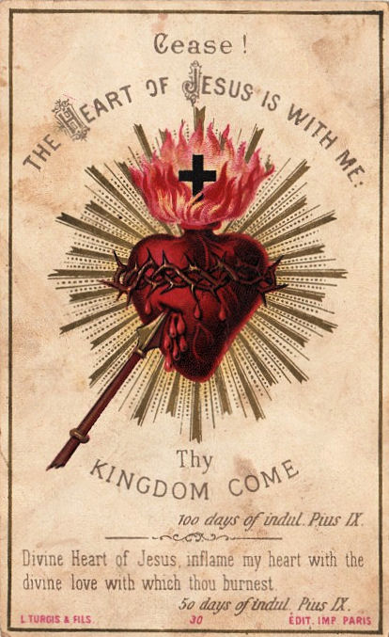](http://www.google.com/url?sa=i&rct=j&q=&esrc=s&frm=1&source=images&cd=&cad=rja&docid=npDjTa6Vc-6hpM&tbnid=rXrK1YjzbLCC7M:&ved=0CAUQjRw&url=http://lordifyouwill.blogspot.com/2012/06/solemnity-of-sacred-heart-of-jesus.html&ei=nV4iUaGgDujriwKr5oD4BA&bvm=bv.42661473,d.cGE&psig=AFQjCNFGxUnXPN9H1h57k_Q1pqBx8xz0sA&ust=1361292965628441)[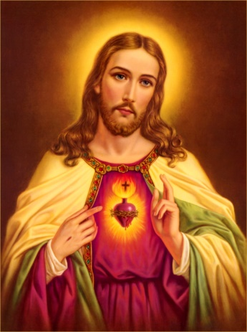](http://www.google.com/url?sa=i&rct=j&q=&esrc=s&source=images&cd=&cad=rja&uact=8&docid=b8zCqI40JoME0M&tbnid=y5JFYu6T_kGfIM:&ved=0CAUQjRw&url=http://devoutlycatholic.wordpress.com/prayer-to-the-sacred-heart-of-jesus/&ei=Vt6oU9TaM9H0oASF5ILQBQ&bvm=bv.69620078,d.cGU&psig=AFQjCNHAqLBWh05n1TVQAWgCWaHNIRFLHw&ust=1403662261256464)

**Sacred Heart of Jesus**

**Celebrated 19 days after** [**Pentecost**](https://en.wikipedia.org/wiki/Pentecost)**.**

O most holy heart of Jesus, fountain of every blessing, I adore you, I love you, and with lively sorrow for my sins I offer you this poor heart of mine. Make me humble, patient, pure and wholly obedient to your will. Grant, [Good](http://www.catholic.org/encyclopedia/view.php?id=5257) Jesus, that I may live in you and for you. Protect me in the midst of danger. Comfort me in my afflictions. Give me health of body, assistance in my temporal needs, your [blessing](http://www.catholic.org/encyclopedia/view.php?id=1948) on all that I do, and the [grace](http://www.catholic.org/encyclopedia/view.php?id=5305) of a holy death. Amen.