[**www.SanctusArt.com**](http://www.SanctusArt.com)

**Sanctus Catholic Art & Saints**

[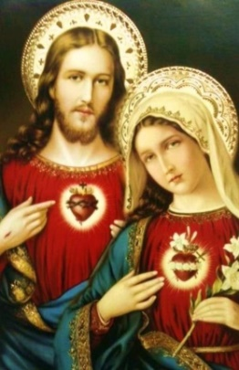](http://www.google.com/url?sa=i&rct=j&q=&esrc=s&source=images&cd=&cad=rja&uact=8&docid=I6wm3dy-l6FPbM&tbnid=9yebexl3n-rrwM:&ved=0CAUQjRw&url=http://www.pinterest.com/pin/22025485649938032/&ei=iPCuU7nZN4HyoATD44GIDA&bvm=bv.69837884,d.cGU&psig=AFQjCNFjSR7B4C5OOzz6hgWm7fqO7W2bYw&ust=1404060165710514)[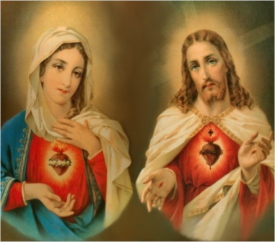](http://www.google.com/url?sa=i&rct=j&q=&esrc=s&source=images&cd=&cad=rja&uact=8&docid=P_Q8d79wdtzLLM&tbnid=EgibrOQu9--bZM:&ved=0CAUQjRw&url=http://www.catholictradition.org/save-souls.htm&ei=xu-uU6PgLYjhoAT63IHoDA&bvm=bv.69837884,d.cGU&psig=AFQjCNEShWUUUk55HOIaVymkVTp4UMTCkA&ust=1404059968423773)

**An Offering of the Hearts of Jesus and Mary**

O Jesus, only Son of God, only Son of Mary, I offer Thee the most loving Heart of Thy divine Mother which is more precious and pleasing to Thee than all hearts.

O Mary, Mother of Jesus, I offer Thee the most adorable Heart of Thy well-beloved Son, who is the life and love and joy of Thy Heart.

Blessed be the Most Loving Heart and Sweet Name of Our Lord Jesus Christ and the most glorious Virgin Mary, His Mother, in eternity and forever. Amen.