[**www.SanctusArt.com**](http://www.SanctusArt.com)

**Sanctus Catholic Art & Saints**

[](http://www.google.com/url?sa=i&rct=j&q=&esrc=s&frm=1&source=images&cd=&cad=rja&docid=MULA3Pxm3azRVM&tbnid=y7ERjlRqeBv3TM:&ved=0CAUQjRw&url=http://www.etsy.com/market/Coraz%C3%B3n?ref%3Dlisting_tag&ei=Rzw_Uu7sFeGviQKZiYDICg&psig=AFQjCNELlT63FXXTivSM3l4gaQAIDt9bbA&ust=1379961816296407)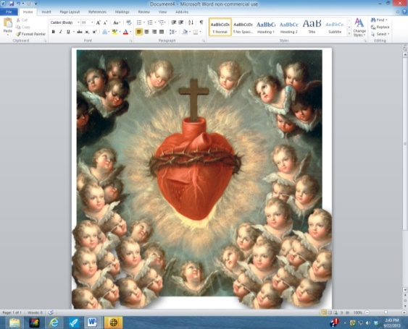[](http://www.google.com/url?sa=i&rct=j&q=&esrc=s&frm=1&source=images&cd=&cad=rja&docid=npDjTa6Vc-6hpM&tbnid=rXrK1YjzbLCC7M:&ved=0CAUQjRw&url=http://lordifyouwill.blogspot.com/2012/06/solemnity-of-sacred-heart-of-jesus.html&ei=nV4iUaGgDujriwKr5oD4BA&bvm=bv.42661473,d.cGE&psig=AFQjCNFGxUnXPN9H1h57k_Q1pqBx8xz0sA&ust=1361292965628441)[](http://www.google.com/url?sa=i&rct=j&q=&esrc=s&source=images&cd=&cad=rja&uact=8&docid=b8zCqI40JoME0M&tbnid=y5JFYu6T_kGfIM:&ved=0CAUQjRw&url=http://devoutlycatholic.wordpress.com/prayer-to-the-sacred-heart-of-jesus/&ei=Vt6oU9TaM9H0oASF5ILQBQ&bvm=bv.69620078,d.cGU&psig=AFQjCNHAqLBWh05n1TVQAWgCWaHNIRFLHw&ust=1403662261256464)

**Act of Consecration to the Sacred Heart**

I, [*state your name*], give myself and consecrate to the Sacred Heart of our Lord Jesus Christ my person and my life, my actions, pains, and sufferings, so that I may be unwilling to make use of any part of my being save to honor, love, and glorify the Sacred Heart.

This is my unchanging purpose, namely, to be all His, and to do all things for the love of Him, at the same time renouncing with all my heart whatever is displeasing to Him.

I therefore take Thee, O Sacred Heart, to be the only object of my love, the guardian of my life, my assurance of salvation, the remedy of my weakness and inconstancy, the atonement for all the faults of my life, and my sure refuge at the hour of death.

Be then, O Heart of goodness, my justification before God Thy Father, and turn away from me the strokes of His righteous anger. O Heart of love, I put all my confidence in Thee for I fear everything from my own wickedness and frailty, but I hope for all things from Thy goodness and bounty.

Do Thou consume in me all that can displease Thee or resist Thy holy will; let Thy pure love imprint Thee so deeply upon my heart, that I shall nevermore be able to forget Thee or to be separated from Thee; may I obtain from all Thy loving kindness the grace of having my name written in Thee, for in Thee I desire to place all my happiness and all my glory, living and dying in very bondage to Thee. Amen.