www.SanctusArt.com
Sanctus Catholic Art & Saints
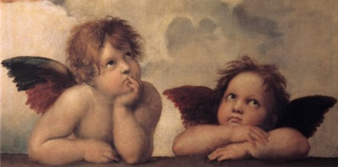
“Raphael’s Angels”
From the Sistine Madonna by Rafael , 1512
“Make yourself familiar with the Angels, and behold them frequently in spirit. Without being seen, they are present with you.” -St. Francis de Sales

