www.SanctusArt.com
Sanctus Catholic Art & Saints
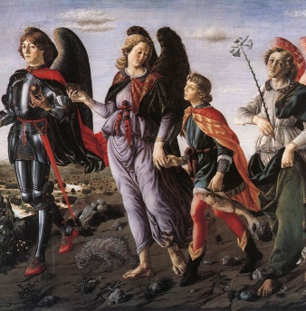
Prayer to all the Archangels
St. Michael, St. Gabriel, St. Raphael, be with me today. Protect me from whatever could cause spiritual or physical harm. Help me be faithful to Jesus and a good communicator of his divine love. Amen.

